Citrix Receiver with new Citrix StoreFront (after 5/13/17)
Any icons that users had manually favorited in their Citrix Receiver under the older Storefront (prior to 5/13/17…Fig. 1), will not be seen by in new Receiver user interface after 5/13/17 (Fig 2). Applications identified as “Mandatory” on Citrix Infrastructure (i.e., Epic-Prod, Network Desktop) will still appear in the “Favorites” and “Apps” tab on the new Receiver by default. However, other manually favorited icons will have to be re-added.
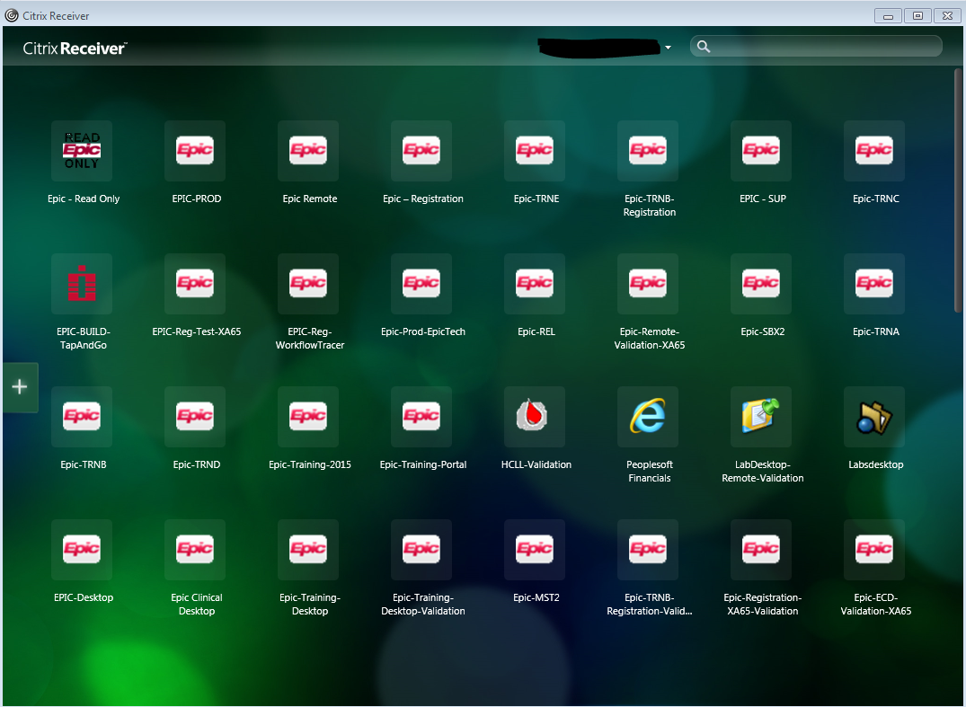
Fig 1

As seen in Fig 2, there are three tabs in new Receiver interface:
- Apps – All the published applications user has permissions for appears here
- Desktops – All the published desktops user has permissions for appears here
- Favorites – All the Published applications/desktops that are marked “mandatory” on Citrix Infrastructure appear automatically here. Other applications used often can be added to the Favorites by clicking on the Details link (Fig 3).
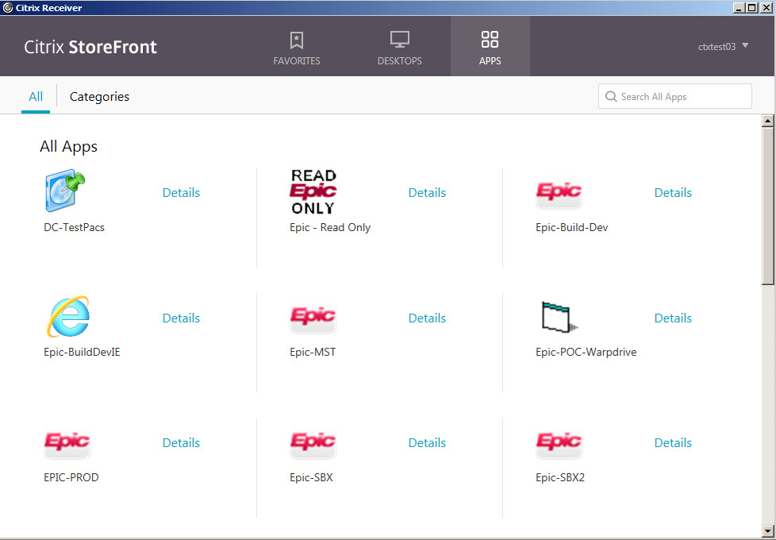
Fig 2
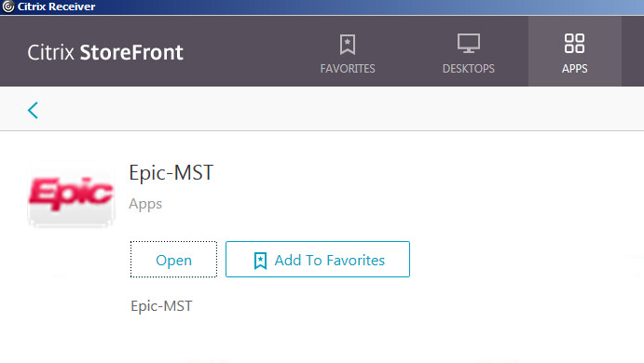
Fig 3

